*DOCKER*

Question 1:

What is Docker?

Answer: Docker is an open-source containerization platform by which you can pack your application and all its dependencies into a standardized unit called a container. Containers are light in weight which makes them portable and they are isolated from the underlying infrastructure and from each other container. You can run the Docker image as a Docker container in any machine where Docker is installed without depending on the operating system.

Question 2:

Answer: Benefits of Docker container.

1. Light weight
2. Applications run in isolation
3. Occupies less space
4. Easily portable and highly secure
5. Short boot up time

Question 3:

How to install Docker?

Answer:

Prerequisites:

* Windows 7 or higher
* 64-bit Operating System
* Download and Install[Linux kernel update package](https://wslstorestorage.blob.core.windows.net/wslblob/wsl_update_x64.msi)

Installation:

Follow the below steps to install Docker on Windows operating system:

Step 1: Visit this website and click on the “Docker Desktop for Windows” button.

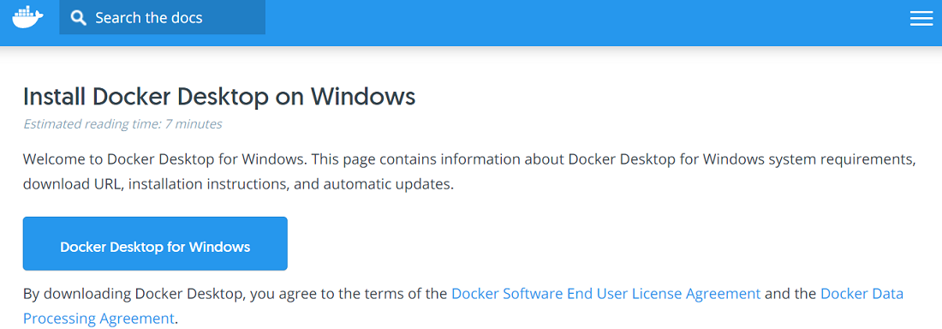

Step 2:

The installer will ask you to install WSL2, so click on the tick box next to it and click on ok. This will download and install WSL2 for you as shown below:

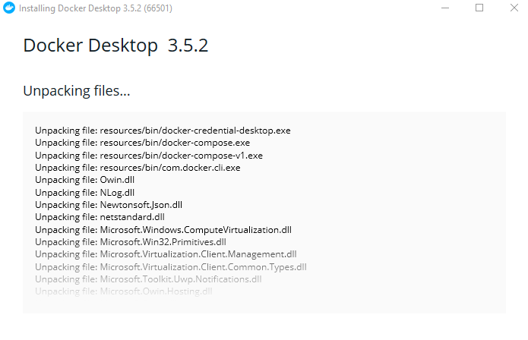

Step 3:

Then we will need to restart our system, so click on “Close and restart” button in the Docker installer window.

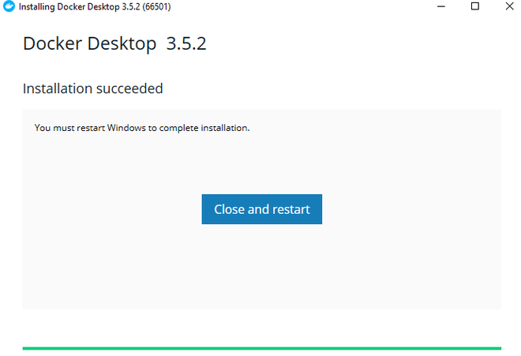

After you restart the computer it will open up the Docker windows as shown below:



At this point we have successfully installed Docker on our Windows operating system. We can verify this using the below command:

docker version

This will result in the following information’s:

